**Exercises on High Voltage Engineering (Mar 20, 2025):**

**Exercise 3-3:** The length of China's first 1000kV AC line silicon rubber composite insulator is 9.75m, and its switching impulse withstand voltage is 1950kV. Under the atmosphere condition of *t*dry=30℃, RH=80% and *p*=99.5kPa, how many kilovolts of switching impulse voltage should be applied to test the insulator?

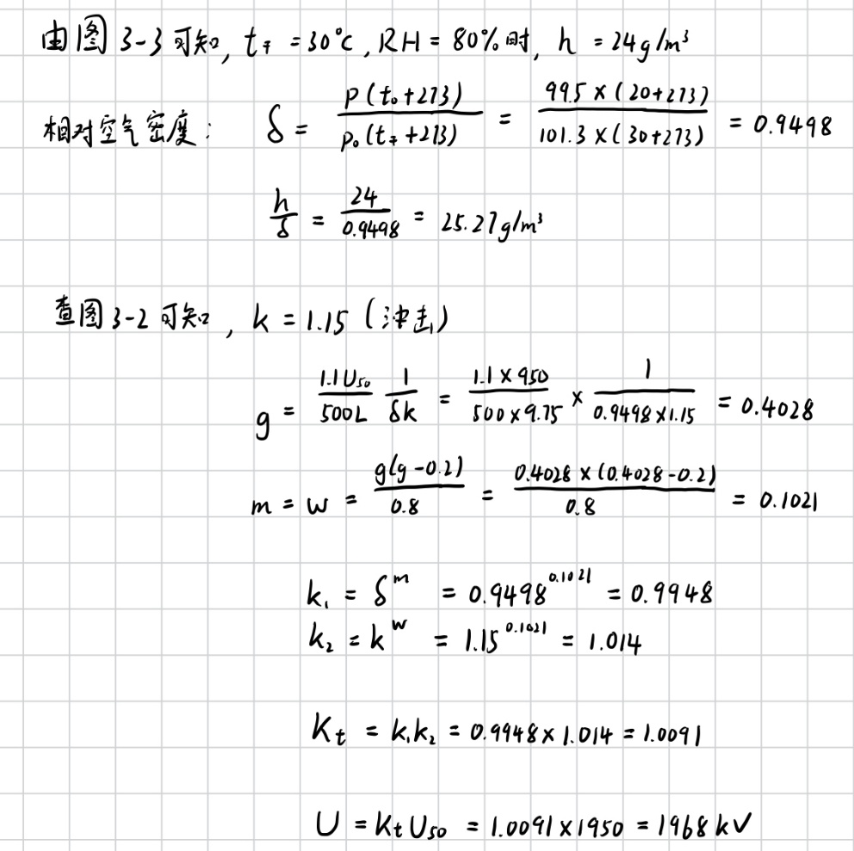

**Exercise 3-7:** What are the ways to improve the sliding spark discharge voltage of a bushing under the power frequency voltage? In order to increase its sliding spark discharge voltage, what is the effect of increasing the surface distance alone?

1. Increase the surface (creepage) distance
2. Improve surface insulation
3. Add sheds (skirts)
4. Enhance surface cleanliness

However, increasing the surface distance alone has limited effect if other factors remain unchanged. For example, if the surface is polluted or moist, the longer path can still become conductive. Moreover, there's a diminishing return after a certain length, especially under wet or contaminated conditions. Thus, a combination of creepage distance, material choice, and structural design is necessary for effectively improving sliding spark discharge voltage.

**Exercise 3-8:** Under the power frequency testing voltage, a bushing just does not occur the phenomenon of sliding spark discharge. If the test voltage amplitude is unchanged, but the standard lightning impulse voltage is applied, can the phenomenon of sliding spark discharge occur or not in the test?

Sliding spark discharge may occur. The initial voltage is negatively correlated with the frequency of the voltage. Since the frequency of lightning impulse voltage is higher than that of power frequency test voltage, the initial voltage is lower, which leads to the occurrence.

**Exercise 3-10:** When the smooth porcelain bushing (*ε*r=6) with an inner diameter of 6cm and a thickness of 3cm, and a inside conductor rod with a diameter of 6cm or 3cm respectively, please try to estimate the sliding spark initiation voltage in these two cases according to the empirical formula.

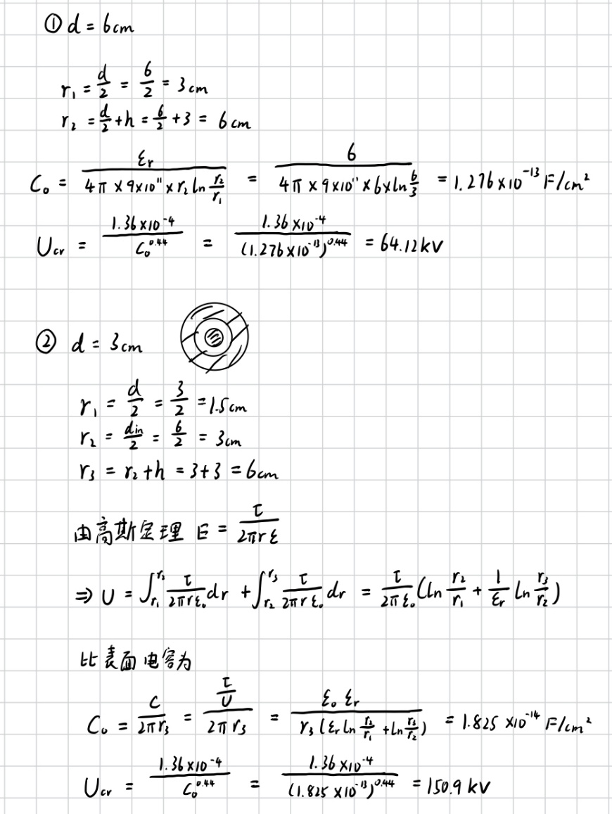

**Exercise 3-11:** The thickness of a glass plate is 2mm, and its *ε*r should be measured by the power frequency sliding spark discharge voltage. The power frequency sliding spark discharge voltage measured in the test is 17kV (rms).

(1) What is the *ε*r of the glass plate?

(2) What is the specific surface capacitance of the glass plate?

一張含有 文字, 字型, 行, 筆跡 的圖片

AI 產生的內容可能不正確。

**Exercise 3-15:** Please describe the requirements for electrical and mechanical performance of insulators briefly.

Electrically, insulators must possess high dielectric strength to withstand both normal operating voltages and transient overvoltages such as lightning and switching surges. They should have excellent insulation resistance and be capable of preventing flashover, especially under adverse environmental conditions like rain, fog, or pollution. Their surface should resist tracking and erosion, which can degrade performance over time. Moreover, the ability to maintain high withstand voltages under both dry and wet conditions is essential to prevent leakage currents and sliding discharges.

Mechanically, insulators must be strong enough to support the weight of conductors and endure mechanical stresses caused by wind, ice loading, or tension in suspension systems. They should have high tensile, bending, or compressive strength depending on their application. Long-term mechanical durability is necessary to avoid failures due to fatigue, vibration, or thermal expansion and contraction. Additionally, their structure must maintain integrity throughout their service life under varying environmental and mechanical conditions.

**Supplementary Exercise 1:** The HV soft wire with a diameter of 3mm passes through the hole of a wall show below. The high voltage generated by the indoor equipment is then guided outdoors for HV testing. The size of the hole is shown in the figure. Under the atmosphere conditions of *t*dry=32℃, *t*wet=28℃, *p*=99.8kPa in summer and *t*dry=12℃, *t*wet 6℃, *p*=104kPa in winter, what is the maximum power frequency AC or positive lightning impulse voltage that can be lead to outdoors without accidental discharge of the HV wire to the wall, or to the door frame and to the ground (the expected withstand voltage can be calculated with 90% breakdown probability)?

High-voltage wire

Wall

Ground

4m

2.25m

**.**

High-voltage wire

2m

2m

Ground

Door frame

Door frame

Door frame

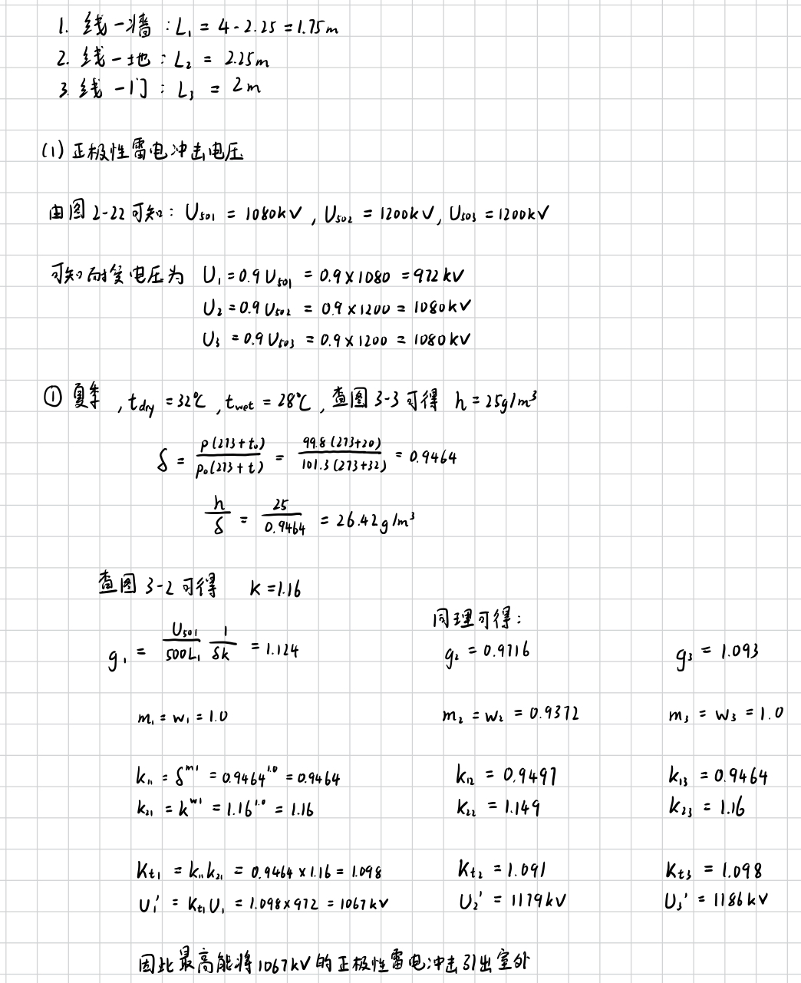

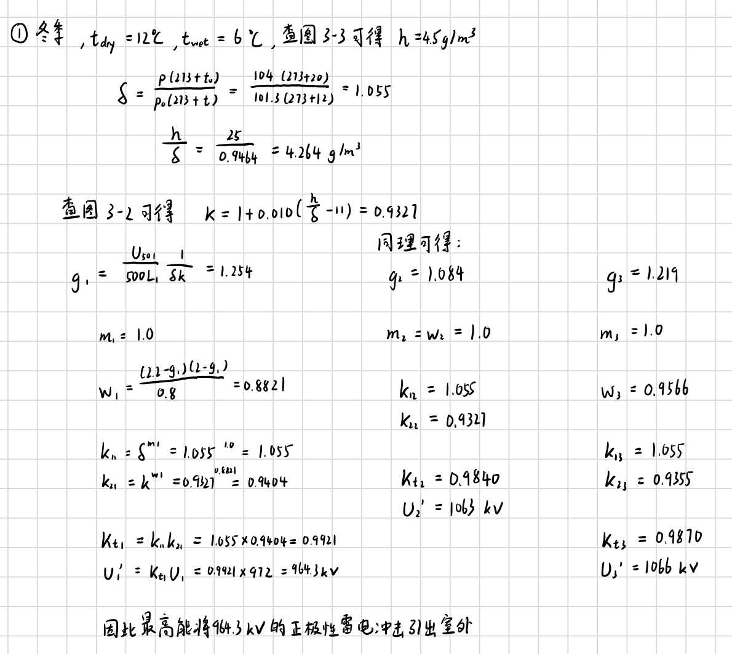 一張含有 文字, 筆跡, 字型, 數字 的圖片

AI 產生的內容可能不正確。

一張含有 文字, 字型, 數字, 筆跡 的圖片

AI 產生的內容可能不正確。

**Supplementary Exercise 2:** In the document on OHLs-1, some photos of OHL self-supporting tower, tensioning tower and guyed tower are given.

(1) As for the OHLs, how are the different conductor configurations realized?

(2) What is the sag of an OHL? What are the factors that affect the sag of conductor?

In Overhead Transmission Lines (OHLs), different conductor configurations are achieved through various tower designs and conductor arrangements, such as vertical, horizontal, or delta formations, depending on voltage level, system requirements, and environmental constraints. Self-supporting towers, tension towers, and guyed towers support these configurations, with bundled conductors often used in high-voltage systems to reduce corona loss and improve efficiency.

The sag of an OHL refers to the vertical distance between the support point and the lowest point of the conductor, ensuring safety clearance and accommodating thermal expansion. Several factors influence sag, including conductor tension (higher tension reduces sag), span length (longer spans increase sag), conductor weight and type (heavier or more elastic materials sag more), temperature (higher temperatures cause expansion and more sag), and environmental loads like wind or ice, which add to the conductor's weight and increase sag accordingly.